Preliminary Agenda
Sunday, 7 July 2024 – Arrival in Bucharest

Monday, 8 July 2024 – Day 1: Corporate Social Responsibility and Social Entrepreneurship
Training location: University Politehnica of Bucharest, Central Library, 2nd floor, Room 2.3

9.00 – 9.30 | Walk-In and Registration, 2nd floor, foyer.  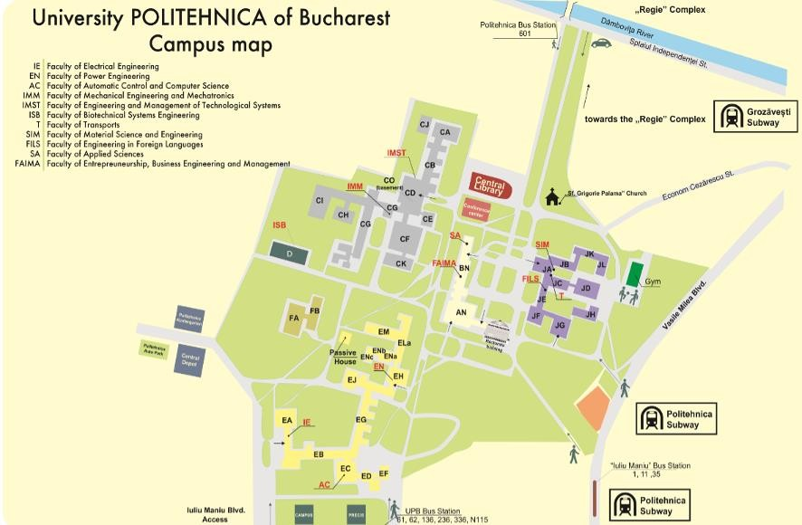
9.30 – 10.00 | Welcome address by the Dean of Faculty for Engineering in Foreign Languages (FILS) and the summer school team

10.00 – 10.30 | - Stations of the weekly program and events from 8th to 12th July: aim, objective, structure
10.30 – 11.00 | Coffee/tea break
11.00 – 12.30 | Getting to know each other and icebreaking conversation
12.30 – 13.30 | Welcome LUNCH at the Central Library, 2nd Floor, Foyer
13.30 – 15.00 | Corporate Social Responsibility and Social Entrepreneurship  - Introduction in Corporate Social Responsibility and Social Entrepreneurship  - How can this approach have a positive and sustainable impact on the company?  - Examples form Social Entrepreneurship in Latvia
15.00 – 15.30 | Coffee/Tea break
15.30 – 16.15 | Examples from Social Entrepreneurship in Latvia
16.15 – 16.30 | Wrap-up: Impressions and Summary. Closing of the day.
Evening | Optional Documentary/Cultural/Social trip for all participants times and locations to be confirmed. (Costs covered by each person)

Tuesday, 9 July 2024 - Day 2: Business Ethics in Innovation and Technology Management
Training location: Politehnica Bucharest, Central Library, 2nd floor, Room 2.3

9.00 – 10.30 | Business Ethics in Innovation and Technology Management in an International Context  - Introduction in Business Ethics
10.30 – 11.00 | Coffee/tea break
11.00 – 12.30 | Ethical Challenges and Best Practices  - Data protection and data security  - Artificial Intelligence and Automation  - Sustainability and Environmental Responsibility

Best Practices and ethical and Decision-making processes
- Ethical guidelines and codes
- Transparency and accountability
12.30 – 13.30 | Lunch break - Central Library, Foyer, 2nd floor
13.30 – 15.00 | Case studies from Austria  - Ethical aspects in the digital transformation  - Challenges and solutions in the start-up ecosystem  - Sustainable innovation processes in the industry  Group work: analysing and presenting the case studies
15.00– 15.30 | Coffee/Tea break
15.30 – 16.00 | Group work: analysing and presenting the case studies
16.00 – 16.15 | All Groups together: Impressions and Summary. Closing of the Day.
Evening | Optional Documentary/Cultural/Social trip for all participants times and locations to be confirmed. (Costs covered by each person)

Wednesday, 10 July 2024 – Day 3: Sustainability and Eco-Innovation
Training location morning session: Politehnica Bucharest, Central Library, 2nd floor, Room 2.3

9.30 – 10.30 | The 17 Sustainable Development Goals/Global Goals  Which are the attributes and key factors of Sustainable Development Coals?  - Sustainability a main key factor  - How should it be visible in the different sectors of the Society?
10.30 – 11.00 | Coffee/Tea break
11.00 – 11.30 | Conclusions: 17 Sustainable Development Goals/Global Goals
11.40 | Travel by the Politehnica bus to the BASF in Bucharest http://www.basf.ro/

Training location in the afternoon session: BASF S.R.L, Floreasca Park, Sos. Pipera nr. 43, Building A, 1st floor, Sector 2.
12.30 – 13.30 | Welcome address by Andreas Lier, CEO of BASF Romania and Bulgaria.  LUNCH with Andreas Lier and his team
13.30 – 15.30 | Workshop: BASF introduction in sustainable product portfolio  - Andreas Lier, CEO of BASF Romania and Bulgaria  - Dr. Rodica Margati, Business Development Manager
15.00 – 15.30 | Coffee/Tea break
15.30 – 16.15 | Impressions and Summary. Informal Get Together. Closing of the day.  (Independent return journey by public transport)
Evening | Optional Documentary/Cultural/Social trip for all participants times and locations to be confirmed. (Costs covered by each person)

Thursday, 11 July 2024 – Cities of tomorrow
Training location in the morning session: AHK Romania, German-Romanian Chamber of Commerce and Industry. Calea Crivitei 82-98, 1st floor, The Mark – Entrace The Podium

9.00 - 9.30 | Travel by the Politehnica bus to German-Romanian Chamber of Commerce and Industry (AHK Romania) https://goo.gl/maps/g3LXqihDsvHqJNdg7
9.30 - 10.00 | Welcome address by Ms Ruxandra Dumitrescu, Deputy Managing Director, Head of the Department Consulting & Services  - Activities of the AHK Romania
10.00 - 11.30 | Cities of tomorrow – Focus on Sustainability: sustainable development of Romanian Cities and Regions
11.30 – 12.00 | Coffee break and Informal Get Together
12.00 | Return by bus to the Campus Politehnica Bucharest
Training location: Politehnica Bucharest, Central Library, 2nd floor, Room 2.3
12.30 -13.30 | Lunch break - Central Library, Foyer, 2nd floor

13.30 - 15.00 | Cities of tomorrow – Working groups – presentations
15.00 - 15.15 | Coffee/Tea break
15.15 – 16.15 | Review of the week – Reflection on activities
16.15 – 16.45 | All Groups together: Impressions and Summary. Closing the day.
Evening | Social networking/Cultural event for all participants to be confirmed. (Costs covered by each person)

Friday, 12 July 2024 - Day 5: Project Day with excursion to Brasov

8.00 – 17.00 | Travel by Politehnica Bus to Brasov  (You will cover the cost of your own meals, as well as entrance fees and other expenses in connection with the excursion.)
Case Example Brasov within the Framework of Green Cities Alliance Romania

- Co-designing a mobility strategy for Brasov. Solution for better life in cities, sustainable and ecofriendly.

Meetings with NGOs and representatives of the city administration who are working together on eco-innovation.
15.00 | Return to Bucharest
17.30 – 18.00 | Impressions and Summary. Awarding of the certificates and closing of the Summer  School.

